- Set up Google Search Console (GSC) for a demo website you control (can be a free GitHub Pages site or any blog you own), and verify ownership using the HTML tag method.
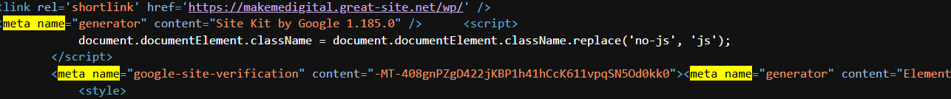

- Submit a sitemap for your demo site in Google Search Console and take a screenshot showing the sitemap status after submission.<br><br><em><strong>Hint:</strong> Use an online sitemap generator if your site does not have one.</em>
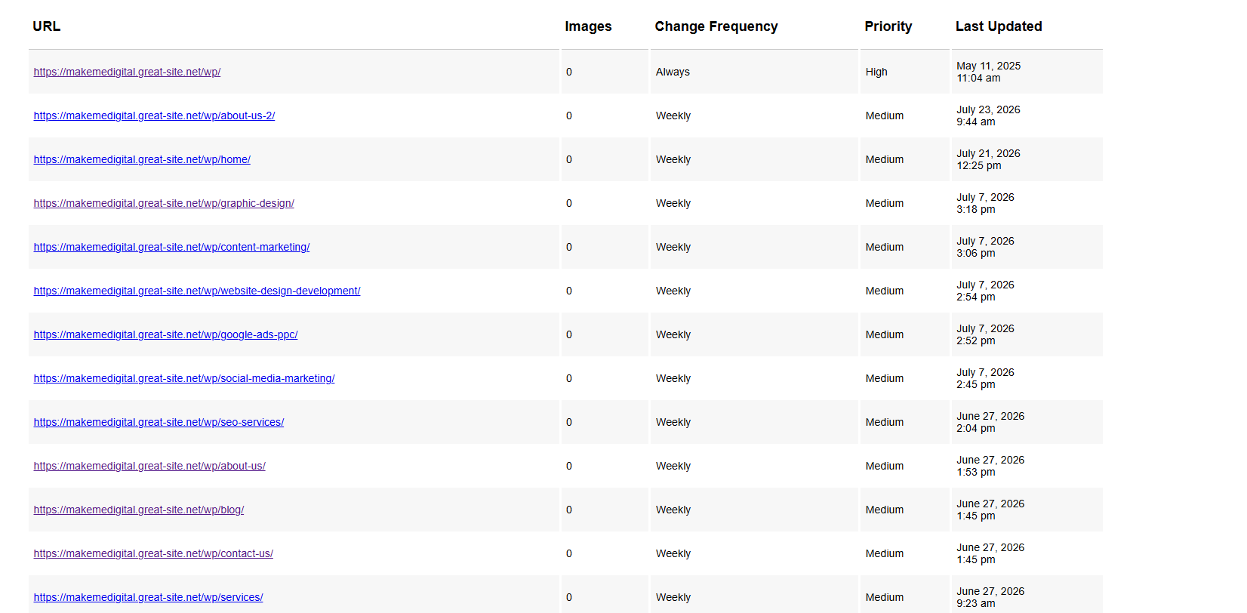
- Use the URL Inspection tool in Google Search Console to inspect a specific page of your site. Request indexing for that page and note any issues or suggestions GSC provides.
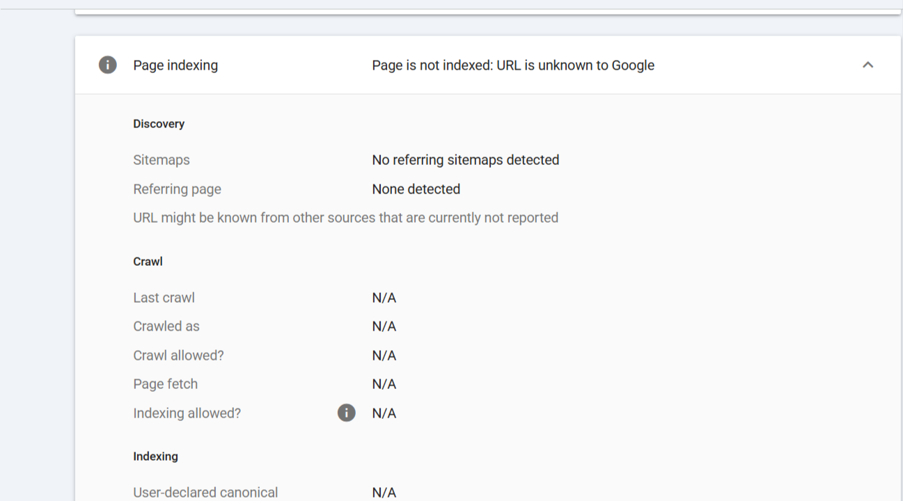

- Apply the GSC Queries Trick: In the Performance report, use a regular expression filter to find queries that are exactly 8 words long (using the pattern '(\b\w+\b\s){7}'). List any queries found, or explain why none appeared.<br><br><em><strong>Hint:</strong> Use the 'Query' filter and select 'Custom (regex)' in GSC.</em>

GSC Queries Trick – 8-Word Queries
I applied the regular expression filter (\b\w+\b\s){7} under Queries → Custom (regex) in Google Search Console for the last 28 days.
Result: No queries were found matching the 8-word query pattern.
This means that, during the selected 28-day period, Google Search Console did not show any search query matching this pattern.

